Love, Laugh, Learn – Walking with Jesus to life in all its fullness, John: 10.10 – Elm Resource Provision Topic LTP 3year programme
Year A
Subject | Autumn 1 | Autumn 2 | Spring 1 | Spring 2 | Summer 1 | Summer 2
Theme | Marvellous Me   | Our World   | Winter  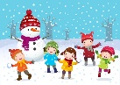 | The woods  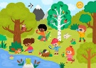 | All creatures great & small  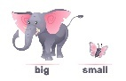 | How does your garden grow?  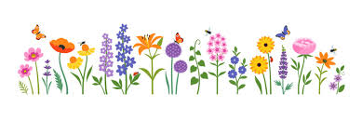
Celebrations | 4th-10th October- Space Week  20thOctober- Diwali | 5th November- Bonfire night  10th-14th November- Antibullying week  25th December- Christmas | 10th February- Safer Internet Day  Chinese New Year | 17thFeb-21st March- Ramadan  15th March- Mother’s Day  Easter Sunday | 2nd April- Autism Awareness Day  20th May- National Numeracy Day | 21st June- Father’s Day
Literacy | Facts & Instructions  Suggested texts:  Who are you? - Smiti Halls  Marvellous Me- Lisa Bullard  Paper Dolls- Julia Donaldson | Poems & Rhymes- Reading for pleasure  Suggested texts:  Peppa’s Christmas Elf- Lauren Holowaty  The Colour Monster- Anna Llenas  Let’s make a rainbow- Chris Ferrie | Traditional tales  Suggested texts:  Little Red Riding Hood  Jack and the Beanstalk  Three Little Pigs | Stories with repetitive patterns  Suggested texts:  Billy Goats Gruff  Goldilocks and the Three Bears | Stories from other cultures  Suggested texts:  Gruffalo- Julia Donaldson  Handa’s Surprise Eileen Browne  Snail and the whale- Julia Donaldson | Fantasy  Suggested texts:  The Singing Mermaid- Julia Donaldson  Pirates Love Underpants- Claire Freedman  Commotion in the Ocean- Giles Andreae
Maths | W1-4: Number  W5-8- Shape & Pattern | W1-2: Number  W3-5: Spatial awareness & Shape  W 6-7: Patterns | W1-2: Number  W3-6: Measures | W1-2: Number  W3-5: Compare | W1-2: Number  W3-4: Cardinality  W5-6: Shape | W1-2: Number  W3-5: Measures  W6-7: Number
Geography | My family, my classroom & local areas | Notice differences in families, how we each celebrate | Places in the world that are hot/ compare to us now- hot and cold | looking at what I looked like as a baby, where I came from and placing on a class map | Exploring farms, how are animals different to me? | Nature, flowers, gardens/fields that surround me
Science | All about me, what I like, my body parts. | Changes in seasons, exploring senses. | Seasonal changes, what happens to ice when… | outdoor areas, changes/ objects & creatures | Compare body parts to different animals | Minibeasts and flowers/ lifecycles
RE | Thankfulness  Jonah and the big fish  Harvest | Respect & Forgiveness  Joseph’s colourful Robe  Nativity | Perseverance  Noah’s Ark | Hope  The Mustard Seed  Easter | Friendship & Love  The Good Samaritan | Courage  The story of Esther  Creation
PSHE | Follow Jigsaw  Being me in my world. | Follow Jigsaw  Celebrating differences | Follow Jigsaw  Dreams and Goals | Follow Jigsaw  Healthy Me | Follow Jigsaw  Relationships | Follow Jigsaw  Changing Me
Art/ DT | Spots & Dots | Painting | Manipulation & Moulding | Shapes & Textures | Building & Creating | Media mark making
Music | Follow Charanga | Follow Charanga | Follow Charanga | Follow Charanga | Follow Charanga | Follow Charanga
Physical Development | Spatial Awareness & Sensory circuits | Balancing & Climbing | Dance, Movement & Actions | Preposition | Shapes and potions- move like animals | Jumping, rolling & position

Year B

Subject | Autumn 1 | Autumn 2 | Spring 1 | Spring 2 | Summer 1 | Summer 2
Theme | Superhero’s  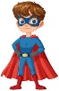 | Wild at heart  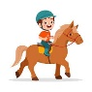 | Out of this world   | Colour Carnival   | Teddies Picnic  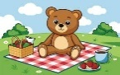 | Sunny seaside  
Celebrations | 4th-10th October- Space Week  20thOctober- Diwali | 5th November- Bonfire night  10th-14th November- Antibullying week  25th December- Christmas | 10th February- Safer Internet Day  Chinese New Year | 17thFeb-21st March- Ramadan  15th March- Mother’s Day  Easter Sunday | 2nd April- Autism Awareness Day  20th May- National Numeracy Day | 21st June- Father’s Day
Literacy | Fantasy  Suggested texts:  10 little superheroes- Mike Brownlow  Zog and the flying doctors- Julia Donaldson | Reading for pleasure  Suggested texts:  Whatever Next- Jill Murphy  Be brave little penguin- Giles Andreae  The Snowman- Raymond Briggs | Stories with repetitive patterns  Suggested texts:  Brown bear. Brown bear, what do you see?- Bill Martin Jr  Dear Zoo- Rod Campbell | Traditional tales  Suggested texts:  Gingerbread Man  Cinderella  The tiger who came for tea- Judith Kerr | Poems & Rhymes  Suggested texts:  Giraffes can’t dance- Giles Andreae  Each peach, pear plum- Allan & Janet Ahlberg | Facts & Instructions  Suggested texts:  What the ladybird heard at the seaside- Julia Donaldson  Here comes the ocean- Meg Fleming
Maths | W1-4: Number  W5-8- Shape & Pattern | W1-2: Number  W3-5: Spatial awareness & Shape  W 6-7: Patterns | W1-2: Number  W3-6: Measures | W1-2: Number  W3-5: Compare | W1-2: Number  W3-4: Cardinality  W5-6: Shape | W1-2: Number  W3-5: Measures  W6-7: Number
Geography | Where I live  My community | My school and areas  Creating map of school | Directions, follow instructions, directional and prepositional | Recognition of familiar places/LOGO’s | Comparison of weather  Effects of rain | Items and locations  What items would I find at a beach?
Science | The human body and the five senses | Naming and describing different materials | Light and Dark  What’s the different? | Seasonal changes  Colours changing outside, why? | Animals, textures and habitats | Healthy choices  Varied diet and exercise
RE | Thankfulness  Jonah and the big fish  Harvest | Respect & Forgiveness  Joseph’s colourful Robe  Nativity | Perseverance  Noah’s Ark | Hope  The Mustard Seed  Easter | Friendship & Love  The Good Samaritan | Courage  The story of Esther  Creation
PSHE | Follow Jigsaw  Being me in my world. | Follow Jigsaw  Celebrating differences | Follow Jigsaw  Dreams and Goals | Follow Jigsaw  Healthy Me | Follow Jigsaw  Relationships | Follow Jigsaw  Changing Me
Art/ DT | Spots & Dots | Painting | Manipulation & Moulding | Shapes & Textures | Building & Creating | Media mark making
Music | Follow Charanga | Follow Charanga | Follow Charanga | Follow Charanga | Follow Charanga | Follow Charanga
Physical Development | Spatial Awareness & Sensory circuits | Balancing & Climbing | Dance, Movement & Actions | Preposition | Shapes and potions- move like animals | Jumping, rolling & position

Year C

Subject | Autumn 1 | Autumn 2 | Spring 1 | Spring 2 | Summer 1 | Summer 2
Theme | Family, Friends & Me   | Rocking around the Christmas tree  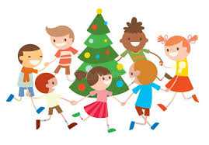 | People who help up  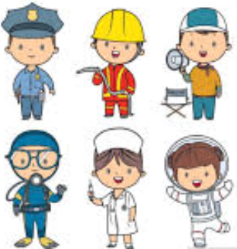 | The big wide world   | Fairy Tales  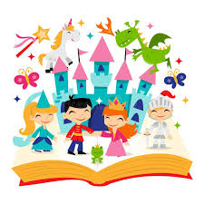 | Transport  
Celebrations | 4th-10th October- Space Week  20thOctober- Diwali | 5th November- Bonfire night  10th-14th November- Antibullying week  25th December- Christmas | 10th February- Safer Internet Day  Chinese New Year | 17thFeb-21st March- Ramadan  15th March- Mother’s Day  Easter Sunday | 2nd April- Autism Awareness Day  20th May- National Numeracy Day | 21st June- Father’s Day
Literacy | Reading for pleasure  Suggested texts:  Be you! - Karl Newson  From head to toe- Eric Carle  All kinds of families- Sophy Henn | Poems & Rhymes  Suggested texts:  Funny Bones- Allan Ahlberg  The runaway pea- Kjartan Poskitt  What the ladybird heard at Christmas- Julia Donaldson | Facts & Instructions  Suggested texts:  Real Superhero’s- Julia Seal  The Jolly Postman- Allan Ahlberg  Dr Maisy- Lucy Cousins | Traditional tales  Suggested texts:  The Gigantic Turnip- Aleksey Tolstoy  Little Red Hen- Mary Mapes Dodge  Goldilocks and the 3 crocodiles- Michael Wayne Rosen | Fantasy  Suggested texts:  The princess and the pea  Snow White  Dragons don’t dance ballet- Jennifer Carson | Stories with repetitive patterns  Suggested texts:  The very hungry caterpillar- Eric Carle  Wriggle and Roar- Julia Donaldson  Spot goes on holiday- Eric Hill
Maths | W1-4: Number  W5-8- Shape & Pattern | W1-2: Number  W3-5: Spatial awareness & Shape  W 6-7: Patterns | W1-2: Number  W3-6: Measures | W1-2: Number  W3-5: Compare | W1-2: Number  W3-4: Cardinality  W5-6: Shape | W1-2: Number  W3-5: Measures  W6-7: Number
Geography | Animals and here they live  What do they need? | Material, movement and manipulation | My family, Classroom and friends. | Maps  Identify familiar places, instruct BeeBots | Places in the world that are hot/ compare to us now- hot and cold | Where have we been, holidays, family
Science | Growing up Humans  Being healthy | Material - Changes in state  Ice melting, making jelly | Animals and their young  Life cycle | Plants- Growing seeds and plants | Seasonal changes  How does the sky look different? | Material- Properties and uses  Hard, soft, mailable.
RE | Thankfulness  Jonah and the big fish  Harvest | Respect & Forgiveness  Joseph’s colourful Robe  Nativity | Perseverance  Noah’s Ark | Hope  The Mustard Seed  Easter | Friendship & Love  The Good Samaritan | Courage  The story of Esther  Creation
PSHE | Follow Jigsaw  Being me in my world. | Follow Jigsaw  Celebrating differences | Follow Jigsaw  Dreams and Goals | Follow Jigsaw  Healthy Me | Follow Jigsaw  Relationships | Follow Jigsaw  Changing Me
Art/ DT | Spots & Dots | Painting | Manipulation & Moulding | Shapes & Textures | Building & Creating | Media mark making
Music | Follow Charanga | Follow Charanga | Follow Charanga | Follow Charanga | Follow Charanga | Follow Charanga
Physical Development | Spatial Awareness & Sensory circuits | Balancing & Climbing | Dance, Movement & Actions | Preposition | Shapes and potions- move like animals | Jumping, rolling & position

